**BLOCK BLOQUE**

Installation and User Instructions

**Team:** Team Rocket

**Members:** Alex Johnson, Sandy Rech, Evan GoFourth, Clay Beabout

**Table of Contents**

1. **Introduction………………………………………………………………. | 3**
   1. Overview
   2. Purpose
   3. Source Code
2. **Installation ……………………………………………………………….. | 5**
   1. Steps
3. **Walkthrough ..………………………………………..………………… | 6**
   1. Home Screen
   2. Level Screens
   3. Pause Menu Screen
   4. End Game Screen
4. **Troubleshooting & Support ……………………………….…… | 10**
   1. Unity
   2. Project Installing
   3. Bug referencing

**1. Introduction**

**__________________________________________**

1. **Overview**

*Block Bloque* is a challenging unblock puzzle game intended to make players use strategy and speed to obtain an optimal score. It is created by Evan GoFourth, Sandy Rech, Alex Johnson and Clay Beabout for EECS 448: Software Engineering. This product is open source and accessible to anyone interested in playing the game or examining our codebase. The project, with exception to documentation notes, was created using the *Unity* video game engine and Microsoft Visual Studio. 57% of the source code is written in C# (Unity’s language of choice) and 36% in ASP. The other 7% is made up of HTML, CSS, Javascript and Objective-C. Other documentation including Gantt Charts, UML Diagrams, Product Backlog, Meeting Logs, Bug list, Deployment plan and Maintenance plan can be found in the DOCUMENTATION folder within the repository.

1. **Purpose**

*Block Bloque* was created to provide players with a fun, simple, competitive and strategy-based game to play with friends. *Bloque’s* User Interface makes the gaming experience fun from the stylish backgrounds to the catchy theme song. By utilizing the scoring and leaderboard system, users can compete against one another in order to optimize their performance and problem-solving skills.

1. **Source Code**

Below is the link to our github page including all source code:

<https://github.com/sandyr97/UnblockPuzzle2>

**__________________________________________**

**2. Installation __________________________________________**

**Steps**

1. Open terminal and move through your computers directories for where you would like to place the project. (The project directory will be copied into the directory you are currently in)
2. Use git clone and the following url to copy the project onto your local machine.
   1. [Using **SSH]** Type the following command into terminal:

git clone [git@github.com:sandyr97/UnblockPuzzle2.git](mailto:git@github.com:sandyr97/UnblockPuzzle2.git)

* 1. [Using **HTTPS]**

<https://github.com/sandyr97/UnblockPuzzle2.git>

1. Track through your computer directories to the location where you placed the project. Blah blah

**__________________________________________**

**3. Walkthrough**

**__________________________________________**

1. **Home Screen**

At the start of the application, you will be directed to the sign in page. Enter a username to record your score later in the game. Hit the play button to begin the game timer and first level.

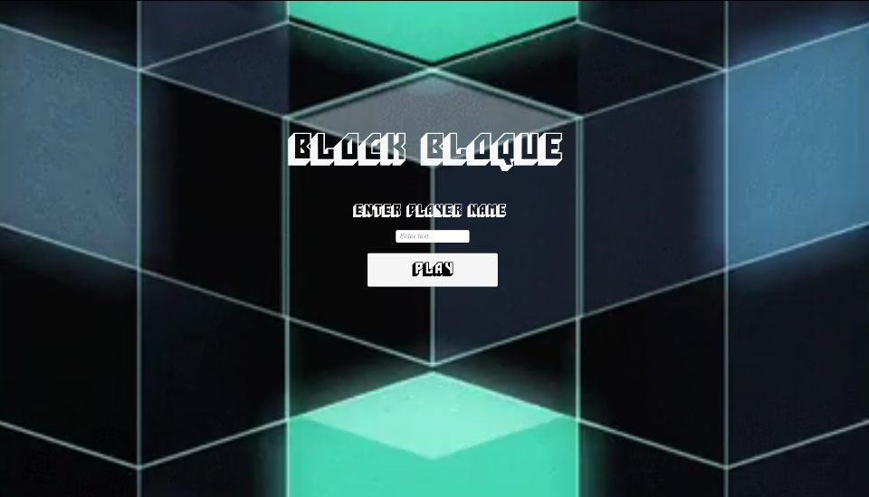

1. **Level Screens**

Header, current level number and game timer will be displayed at the top center of the screen. The game board will be displayed to the left-most side of the screen with the running game timer and a *Welcome username* banner on the right-most side of the screen. Each block, both **red** and **black** can be dragged in the direction of the elongated side.

* **Horizontally Long (WIDE)** blocks can be dragged left/right
* **Vertically Long (TALL)** blocks can be dragged up/down

Move the blocks around strategically with the goal of touching the two **red blocks** together. If the two **red blocks** make contact, you will be redirected to the next level.



1. **Pause Menu Screen**

When on a level screen, hit esc to enter the Pause Menu Screen and temporarily stop the game timer. Below you will find click responses and page redirect information for each of the respective Pause Menu options

* **Resume:** Returns you to the level you were currently playing and resumes the game timer.
* **Reset Level:** Resets the game board and blocks to their initial positions but does not reset the game timer.
* **Main Menu**: Redirects you back to the sign in page and current username and scoring data will be thrown away.
* **Quit:** Closes the application and current username and scoring data will be thrown away.
* **Master Volume:** Drag the circle on the bar to adjust the *Block Bloque* theme music volume.

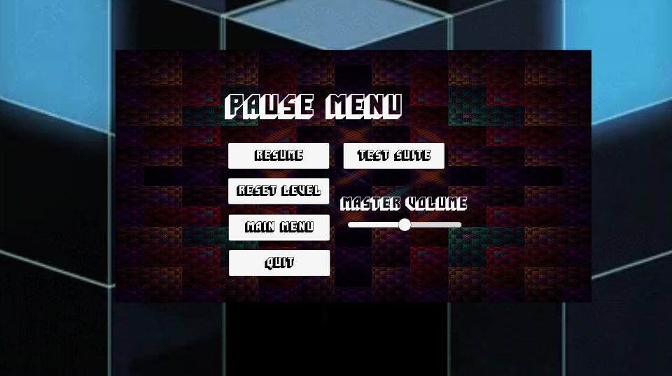

**img:** Pause menu screenshot

1. **Test Suite Screen**

blah blah



**img:** Test Suite screenshot

1. **End Game Screen**  
   blah blah



**img:** End game screenshot

**__________________________________________**

**4. Troubleshooting Support**

**__________________________________________**

1. For **Unity** issues, refer to:

<https://docs.unity3d.com/Manual/TroubleShooting.html>

1. For **project downloading** issues, refer to:

<https://git-scm.com/book/en/v1/Git-Basics-Getting-a-Git-Repository>

1. For **bug** issues, refer to our bugs document in the project folder for known/non-fixed bugs